# Data 607: Group 7 Project 3

Due to time constraints, the group has decided not to implement the database. We do not have an existing shared environment that would allow us to access the database from anywhere. To cover the database requirement of the project, we’ve decided to present a design of the concept of how we would incorporate this database in our project.

# Overall Workflow

* Job posting URLs are going to be stored to a table
* Output from web scraping is going to be stored in a table
* Output from text mining is going to be stored in a table
* Clean data
* Term document matrix
* Term Frequency

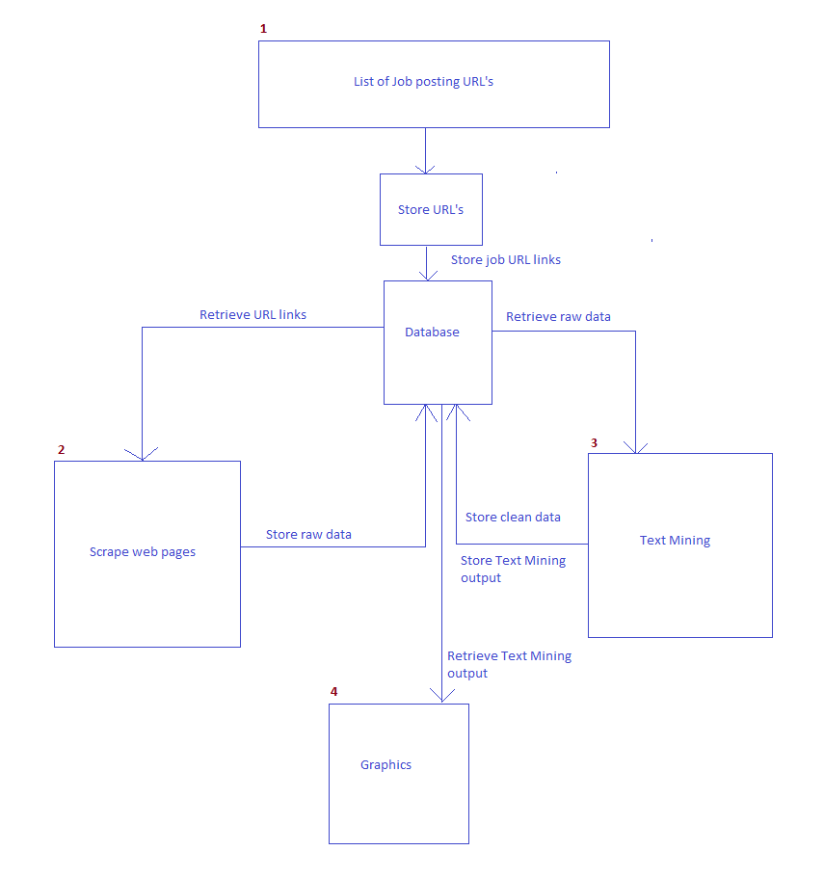

# Database Table Schema

Tables

* job_website_info: stores website name
* job_urls: stores each URL source
* job_rawText: stores data scraped from the URL location
* job_cleanText: stores the clean version of the data
* term_document_matrix: stores the term document matrix output of the job
* term_frequency_adjusted: stores the term frequency output of the job

NOTE:

For data that could change with each run, a *process_id* is added. This id will be provided by the job. This design would allow us to analyze previous runs if necessary.

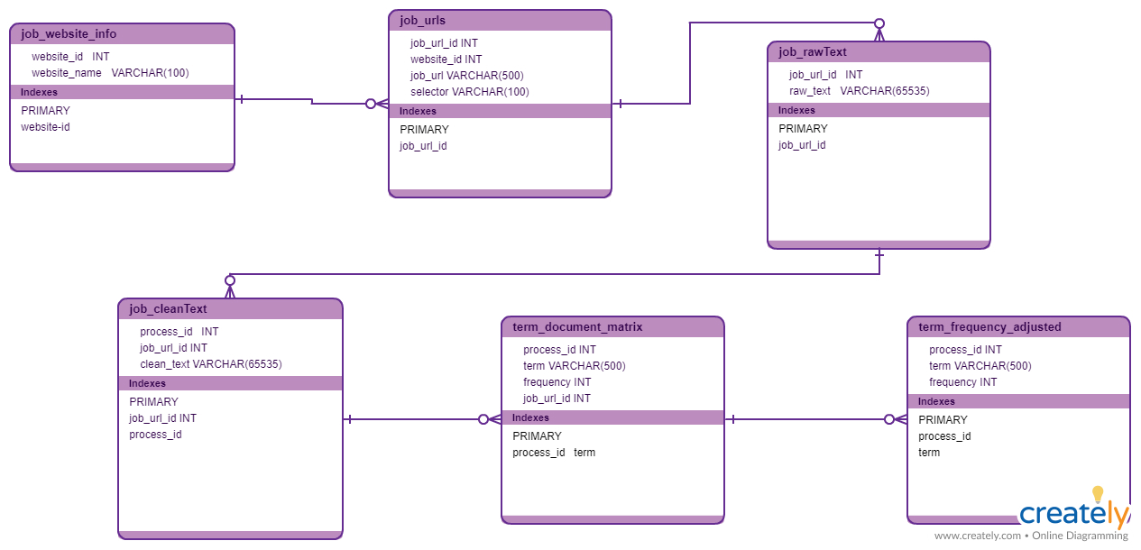

# Create Table Statements

CREATE DATABASE DATA607_GROUP7_PROJECT3;

USE DATA607_GROUP7_PROJECT3;

CREATE TABLE job_website_info(

website_id INT,

website_name VARCHAR(100),

PRIMARY KEY(website_id)

);

CREATE TABLE job_urls (

job_url_id INT,

website_id INT,

job_url VARCHAR(500),

selector VARCHAR(100),

PRIMARY KEY(job_url_id)

);

CREATE TABLE job_rawText (

job_url_id INT,

raw_text VARCHAR(65535),

PRIMARY KEY(job_url_id)

);

CREATE TABLE job_cleanText (

process_id INT,

job_url_id INT,

clean_text VARCHAR(65535),

PRIMARY KEY(process_id, job_url_id)

);

CREATE TABLE term_document_matrix(

process_id INT,

term VARCHAR(500),

frequency INT,

job_url_id INT,

PRIMARY KEY(process_id, term)

);

CREATE TABLE term_frequency_adjusted(

process_id INT,

term VARCHAR(500),

frequency INT,

PRIMARY KEY(process_id, term)

)